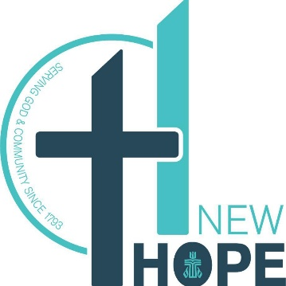
Director of Youth and Children
POSITION DESCRIPTION

POSITION DESCRIPTION

The DYC will organize and resource NHPC’s Christian Education programs, with an emphasis on children and youth, to include training church members for the task of teaching and leading Christian Education in a shared capacity. In working with children and youth, the DYC will foster faith formation and support their families.
This is initially a 10-hour per week position, hopefully increasing to a 20 hour per week position. It includes mandatory Sunday morning obligations (and others that arise) as well as participating in weekly staff meetings, creating and leading weekly program(s) for youth and children, and monthly Christian Education Committee (CEC) meetings.
QUALIFICATIONS
The DYC shall have at minimum a high school diploma and sufficient training and experience necessary to assist in nurturing the life of the church. S/he shall have a passion for Christian Education and shall possess the characteristics and qualities necessary for working harmoniously, effectively, creatively, and confidentially with church members across all populations, the Pastor, and other church staff. Additionally, s/he must enjoy interacting with people and building relationships, be able to work with minimal direction, be dependable, be adaptable and flexible, and detail-oriented.
RESPONSIBILITIES

- Acquire and adapt curriculum to align with relevant Christian standards.
- Share in the leadership of worship, including participation in the children’s time.
- Plan and implement a short-term summer program for children, including recruiting and resourcing teachers.
- Plan and implement a weekly program(s) for children and youth
- Advise the Worship Committee regarding appropriate worship material for children.
- Serve as needed in teaching and education leadership roles.
- Coordinate special programming with the CEC.
- Coordinate youth activities.
- Prepare and submit an annual budget in collaboration with the Chair of the CEC and operate within its parameters. (This is to be done each August for the upcoming year.)
- Provide information for the bulletin, newsletter, and social media to communicate CE activities.
- Follow NHPC’s “Policy for the Protection of our Children and Youth”.
- Perform other duties from time to time as may be directed by the Pastor.

SALARY: Commensurate with experience

ACCOUNTABILITY: The DYC will be supervised by the Pastor.

CONDITION OF EMPLOYMENT: Pass both a reference and background check.

PERFORMANCE REVIEW: Will occur 90 days after employment and at least annually thereafter.

